CSE2102: Introduction to Software Engineering

Analyze into UML

Instructor: Therese Smith

Jianxing Ke

02/18/2015

1. Diagrams of Rapla

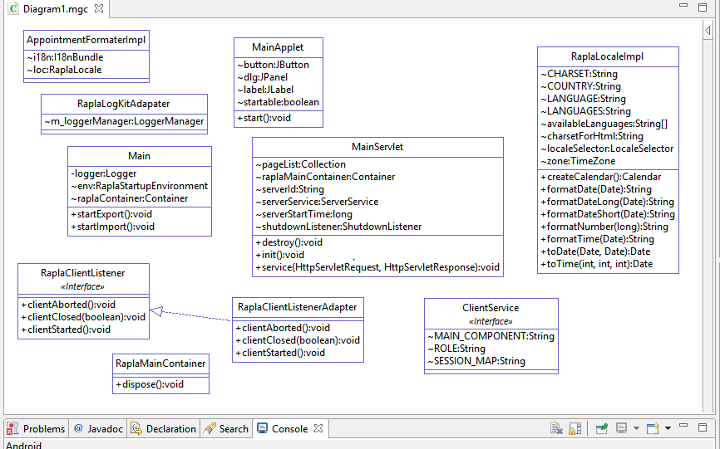

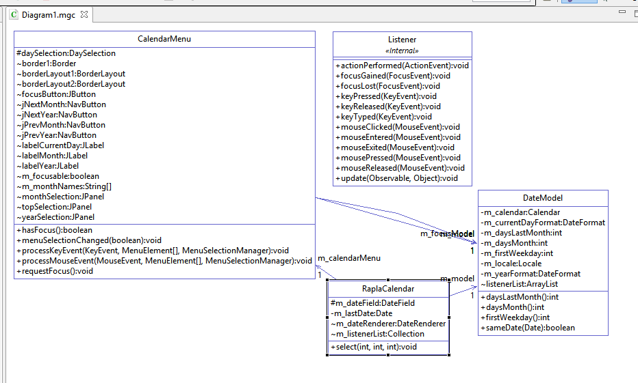

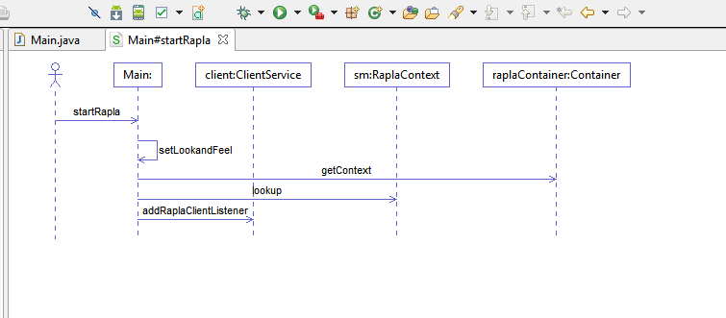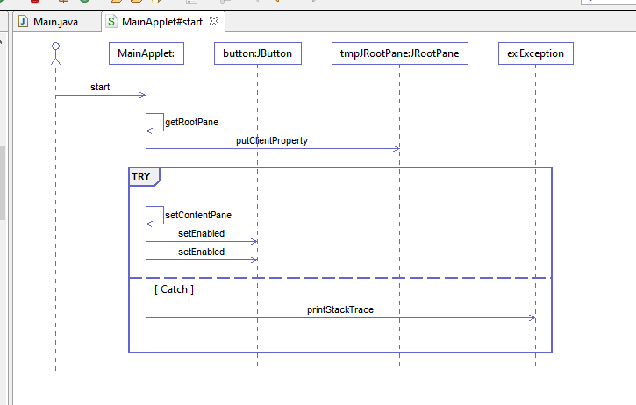

UML diagram of my project

